ASR:

Request to capture DOC collection date by scan DN# for all orders under JNJ.

Added request: 11 Mar 2016

Regarding the DOCS Scanning portion, and we would like have two pop up Colum for Scanning.  
  
Option (1) DN#   
Option (2) SAP/Doc Ref# Is for the Cover Page Scanning.  
  
Kindly refer to the screen shot as below:-

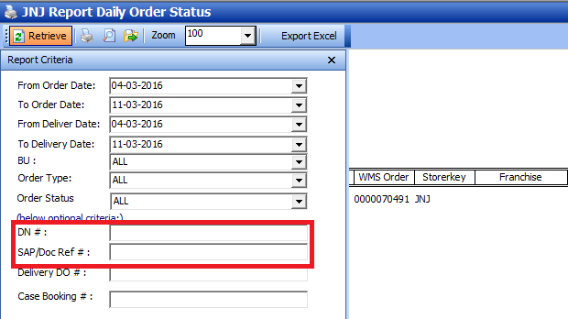

( SAP/Docs Ref ) 
Is a cover page for Multiple Invoices.  
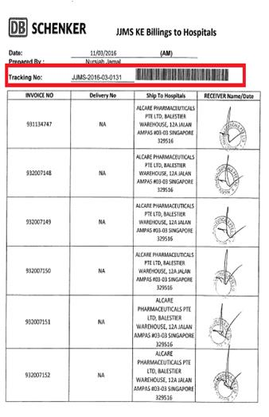

--------------------------------------------------------------------------------------------------------------------------

**From:** Beiron, Lam   
**Sent:** Wednesday, 09 March, 2016 5:28 PM  
**To:** Chan, Pei-Fong  
**Cc:** Yusouff, Mohammed; Tay, James; Serene, Ng  
**Subject:** Request for adinational function .

Hi Pei Fong,

Request for additional function:-

1. Request for additional feature allow us for Scanning DN number ( Eg: Delivery Note# 806013535), to capture DOC collection.
2. Daily Orders Status Report Add one more Colum for Scanning prove once document received. ( Date and DOC Received )
3. Outstanding collection “pending for Document” ( Pending DOC )

The access control :

No other user allow to excess the scanning function.

Is it possible only both of us have the excess to perform the Scanning?

Mohammed Yusouff

Beiron Lam Chit Kong

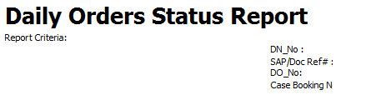

Appreciate your help with Thanks

Beiron Lam (Mr)

**籃焌鋒**

Asst. Supervisor

Contract Logistic/SCM

Schenker Singapore (Pte) Ltd

2 Changi South Street 2, Level 3

Singapore (486759)

DID: +65 65491292 Fax: +65 65499227

Email: [chit-kong.lam@dbschenker.com](mailto:chit-kong.lam@dbschenker.com)